

Name: Muhammad Faisal
Roll no: 2022F-BCS-152

Section: C
Instructor Name:
Course: Operating Systems Lab
Program: (BS) - Computer Science

Lab #01

Task 1: List all files in the current directory.

Task 2: List all files in human readable form.
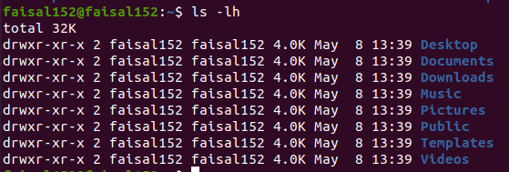

Task 3: Display your current directory.
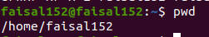

Task 4: Change to the / directory.
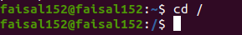

Task 5: Go to the ~ directory from the root directory.
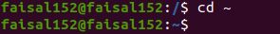

Task 6: List the contents of the root directory.

Task 7: List the files in /boot in a human readable format.
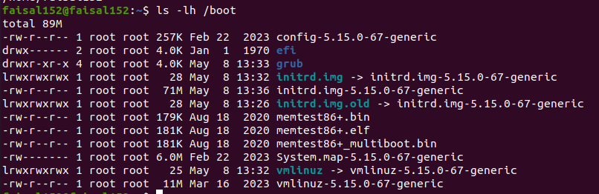

Task 8: Create a directory testdir in your ~ directory.

Task 9: Create in one command the directories ~/dir1/dir2/dir3 (dir3 is a subdirectory from dir2,
and dir2 is a subdirectory from dir1 ).

Task 10: Remove the directory testdir.

Task 11: Move TesingDir from ~ to ~/Tests directories.
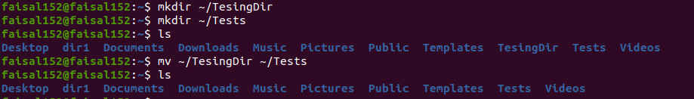

Task 12: Rename a directory from TesingDir to testingDir

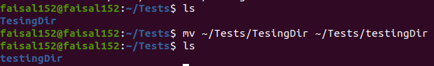

Lab #02

Task 1: Use ls to output the contents of the /etc/ directory to a file called etc.txt.
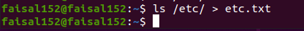

Task 2: Make a file bioData.txt and check that it contains your name using grep,also use i & v flags.
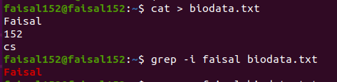

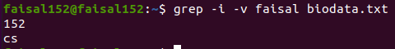

Task 3: Append information in bioData.txt.
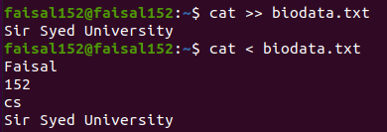

Task 4: Sort the file number.txt using flags.
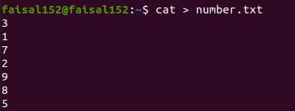
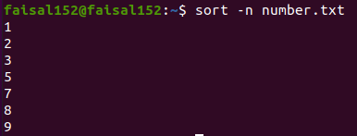

Task 5: Show all the information like total lines, total words and total character inside of your file.
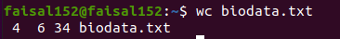

Task 6: Change case of the letters of your file bioData.txt.
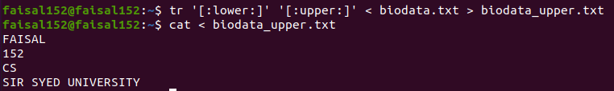

Task 7: Implement stderr (2> and 2>&1).
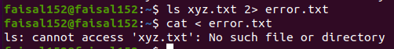

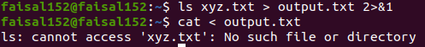

Task 8: Show last 5 data from numbers.txt
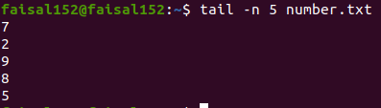

Task 9: Count all duplicates in your file bioData.txt
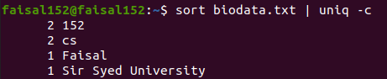

Task 10: Show your os version.
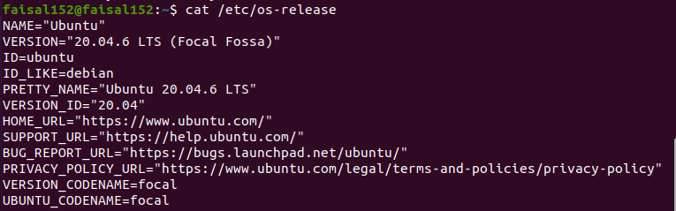

Task 11: Compress the file bioData.txt using gzip and bzip2 algorithm.

Task 12: Show contents of the file bioData.txt.gz without decompressing.
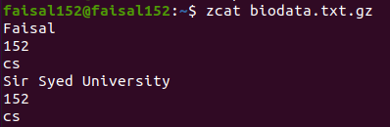

Lab #03

Task 1: Create two groups webProject and SQA.

Task 2: Create two users , user1 and user2 and add them in a group webProject and SQA
respectively.

Task 3: Show All users.
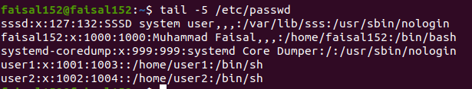

Task 4: Show All groups.
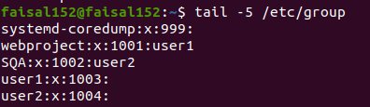

Task 5: Set user1 as group member of SQA.

Task 6: Switch to user2.

Task 7: Create a filename OSLabFile.txt and change its permission , read and execute only in group & user.
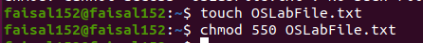

Task 8: Delete user1
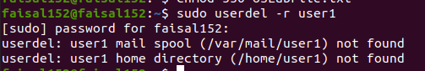

Task 9: Delete SQA.

Task 10: Change password of user1.

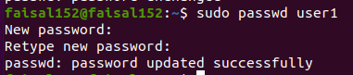

Lab #04

Task 1: Create a MyInfo.txt using vi editor.

Task 2: Write Your name , roll number and section in MyInfo.txt
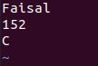
Task 3: Save the File.
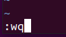
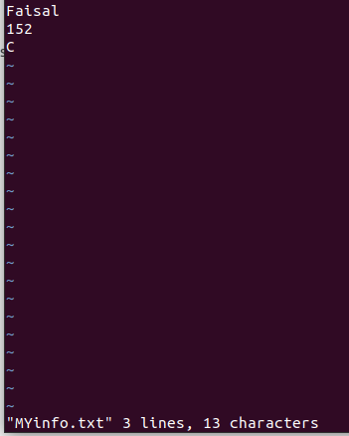



Task 4: Delete your section from MyInfo.txt.
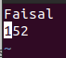

Task 5: Show content of MyInfo.txt using cat.
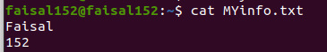

Task 6: Print host name
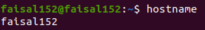

Task 7: Print your(system) user name.
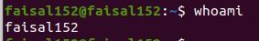

Task 8: Show the locatoin where ls ,pwd ,rmdir & cat source code is present.

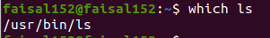

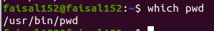

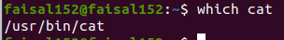
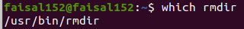

Lab #05

Task 1: Create a file OSLabFile5.1 with date & time 25th January, 2025 3:00 PM.

Task 2: Find the binary and source file location of “ls” command
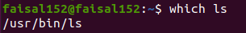
- Finding the Binary Location

- Finding the Source file Location

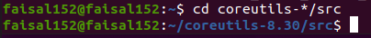

Task 3: Creates 5 threads each thread prints a "Hello World!" message, and then terminates.

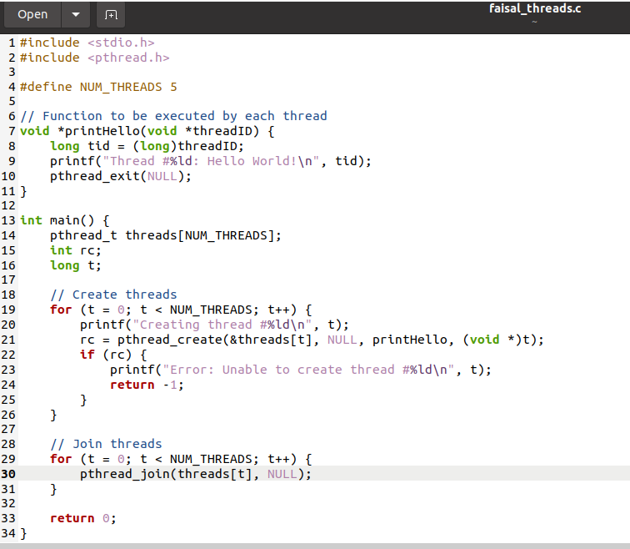

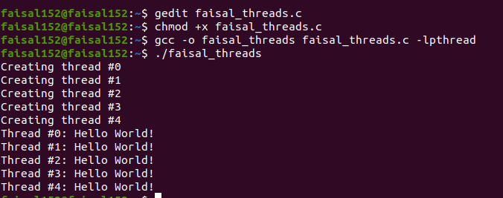

Lab #06

Task 1. For below processes, write FCFS and SJF processes to calculate waiting time for each process and average waiting time.

Process | Arrival Time | Execute Time
P0 | 0 | 5
P1 | 1 | 3
P2 | 2 | 8
P3 | 3 | 6

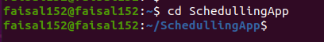

FCFS

using System;
using System.Collections.Generic;

public class Process
{
public int Id { get; set; }
public int ArrivalTime { get; set; }
public int BurstTime { get; set; }
public int OriginalBurstTime { get; set; }
public int WaitingTime { get; set; }
public int TurnaroundTime { get; set; }

public Process(int id, int arrivalTime, int burstTime)
{
Id = id;
ArrivalTime = arrivalTime;
BurstTime = burstTime;
OriginalBurstTime = burstTime;
WaitingTime = 0;
TurnaroundTime = 0;
}
}

public class FCFS
{
public List<Process> Processes { get; set; }

public FCFS(List<Process> processes)
{
Processes = processes;
}

public void Schedule()
{
int currentTime = 0;
int n = Processes.Count;

// Sort processes by arrival time (though FCFS doesn't strictly require this)
Processes.Sort((a, b) => a.ArrivalTime.CompareTo(b.ArrivalTime));

foreach (var proc in Processes)
{
// Process each job in arrival order
if (proc.ArrivalTime > currentTime)
{
currentTime = proc.ArrivalTime;
}

proc.WaitingTime = currentTime - proc.ArrivalTime;
proc.TurnaroundTime = proc.WaitingTime + proc.BurstTime;
currentTime += proc.BurstTime;
}
}

public void DisplayResults()
{
int totalWaitingTime = 0;
int totalTurnaroundTime = 0;

Console.WriteLine();
Console.WriteLine("Process\tArrival\tBurst\tWaiting\tTurnaround");
foreach (var proc in Processes)
{
Console.WriteLine($"{proc.Id}\t{proc.ArrivalTime}\t{proc.OriginalBurstTime}\t{proc.WaitingTime}\t{proc.TurnaroundTime}");
totalWaitingTime += proc.WaitingTime;
totalTurnaroundTime += proc.TurnaroundTime;
}

float averageWaitingTime = (float)totalWaitingTime / Processes.Count;
float averageTurnaroundTime = (float)totalTurnaroundTime / Processes.Count;

Console.WriteLine();
Console.WriteLine($"Average Waiting Time: {averageWaitingTime:F2}");
Console.WriteLine($"Average Turnaround Time: {averageTurnaroundTime:F2}");
}
}

public class Program
{
public static void Main()
{
List<Process> processes = new List<Process>();

Console.Write("Enter the number of processes: ");
int numberOfProcesses = Convert.ToInt32(Console.ReadLine());

for (int i = 1; i <= numberOfProcesses; i++)
{
Console.WriteLine();
Console.Write($"Enter arrival time for process {i}: ");
int arrivalTime = Convert.ToInt32(Console.ReadLine());
Console.Write($"Enter burst time for process {i}: ");
int burstTime = Convert.ToInt32(Console.ReadLine());

processes.Add(new Process(i, arrivalTime, burstTime));
}

// Create an FCFS scheduler
FCFS fcfs = new FCFS(processes);

// Schedule the processes
fcfs.Schedule();

// Display the results
fcfs.DisplayResults();

Console.ReadLine();
}
}

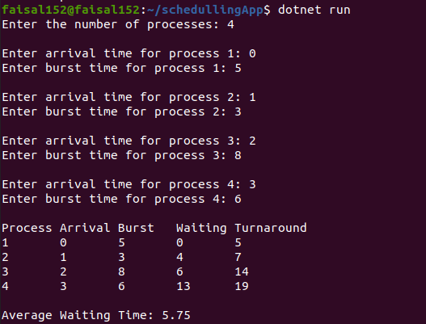

SJF

using System;
using System.Collections.Generic;

public class Process
{
public int Id { get; set; }
public int ArrivalTime { get; set; }
public int BurstTime { get; set; }
public int OriginalBurstTime { get; set; }
public int WaitingTime { get; set; }
public int TurnaroundTime { get; set; }

public Process(int id, int arrivalTime, int burstTime)
{
Id = id;
ArrivalTime = arrivalTime;
BurstTime = burstTime;
OriginalBurstTime = burstTime;
WaitingTime = 0;
TurnaroundTime = 0;
}
}

public class ShortestJobFirst
{
public List<Process> Processes { get; set; }

public ShortestJobFirst(List<Process> processes)
{
Processes = processes;
}

public void Schedule()
{
// Sort processes based on arrival time, then burst time
Processes.Sort((a, b) => {
int compareArrival = a.ArrivalTime.CompareTo(b.ArrivalTime);
if (compareArrival == 0)
{
return a.BurstTime.CompareTo(b.BurstTime);
}
return compareArrival;
});

int currentTime = 0;
int completedProcesses = 0;
int n = Processes.Count;

while (completedProcesses < n)
{
// Find the next shortest job that has arrived
Process shortestProcess = null;
for (int i = 0; i < n; i++)
{
Process proc = Processes[i];
if (proc.ArrivalTime <= currentTime && proc.BurstTime > 0)
{
if (shortestProcess == null || proc.BurstTime < shortestProcess.BurstTime)
{
shortestProcess = proc;
}
}
}

if (shortestProcess != null)
{
// Process the shortest process found
currentTime += shortestProcess.BurstTime;
shortestProcess.TurnaroundTime = currentTime - shortestProcess.ArrivalTime;
shortestProcess.WaitingTime = shortestProcess.TurnaroundTime - shortestProcess.OriginalBurstTime;

// Mark the process as completed
shortestProcess.BurstTime = 0;
completedProcesses++;
}
else
{
// If no process found to execute, just increment the time
currentTime++;
}
}
}

public void DisplayResults()
{
int totalWaitingTime = 0;
int totalTurnaroundTime = 0;

Console.WriteLine();
Console.WriteLine("Process\tArrival\tBurst\tWaiting\tTurnaround");
foreach (var proc in Processes)
{
Console.WriteLine($"{proc.Id}\t{proc.ArrivalTime}\t{proc.OriginalBurstTime}\t{proc.WaitingTime}\t{proc.TurnaroundTime}");
totalWaitingTime += proc.WaitingTime;
totalTurnaroundTime += proc.TurnaroundTime;
}

float averageWaitingTime = (float)totalWaitingTime / Processes.Count;
float averageTurnaroundTime = (float)totalTurnaroundTime / Processes.Count;

Console.WriteLine();
Console.WriteLine($"Average Waiting Time: {averageWaitingTime:F2}");
Console.WriteLine($"Average Turnaround Time: {averageTurnaroundTime:F2}");
}
}

public class Program
{
public static void Main()
{
List<Process> processes = new List<Process>();

Console.Write("Enter the number of processes: ");
int numberOfProcesses = Convert.ToInt32(Console.ReadLine());

for (int i = 1; i <= numberOfProcesses; i++)
{
Console.WriteLine();
Console.Write($"Enter arrival time for process {i}: ");
int arrivalTime = Convert.ToInt32(Console.ReadLine());
Console.Write($"Enter burst time for process {i}: ");
int burstTime = Convert.ToInt32(Console.ReadLine());

processes.Add(new Process(i, arrivalTime, burstTime));
}

// Create a SJF scheduler
ShortestJobFirst sjf = new ShortestJobFirst(processes);

// Schedule the processes
sjf.Schedule();

// Display the results
sjf.DisplayResults();

Console.ReadLine();
}
}

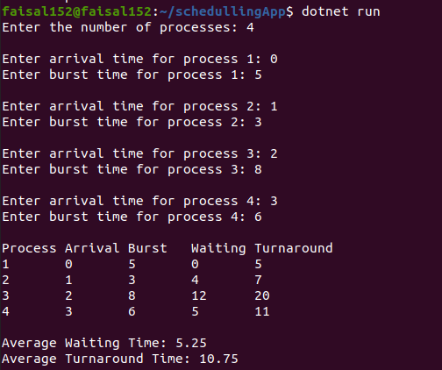

Task 2: For below processes, write FCFS and SJF processes to calculate waiting time for each process and average waiting time.

Process | Arrival Time | Execute Time
P0 | 2 | 6
P1 | 5 | 2
P2 | 1 | 8
P3 | 0 | 3
P4 | 4 | 4

FCFS
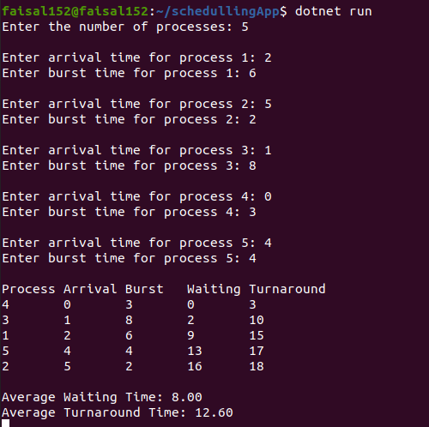

SJF
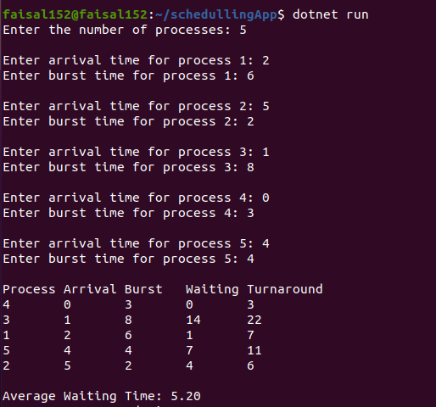

Lab #07

Task 1: Perform the above code with 8 Number of processes by randomly setting the arrival time and burst time and priority.
(a) Use Round Robin Algorithm
(b) Use Priority Based Algorithm

(a)



using System;

class GFG
{
public static void roundRobin(String[] p, int[] a, int[] b, int n)
{
// Result of average times
int res = 0;
int resc = 0;

// For sequence storage
String seq = "";

// Copy the burst array and arrival array for not affecting the actual array
int[] res_b = new int[b.Length];
int[] res_a = new int[a.Length];

for (int i = 0; i < res_b.Length; i++)
{
res_b[i] = b[i];
res_a[i] = a[i];
}

// Critical time of system
int t = 0;

// For store the waiting time
int[] w = new int[p.Length];

// For store the Completion time
int[] comp = new int[p.Length];

while (true)
{
bool flag = true;
for (int i = 0; i < p.Length; i++)
{
// These conditions are for if arrival is not on zero

// Check that if they come before quantum time
if (res_a[i] <= t)
{
if (res_a[i] <= n)
{
if (res_b[i] > 0)
{
flag = false;
if (res_b[i] > n)
{
// Make decrease the burst time
t = t + n;
res_b[i] = res_b[i] - n;
res_a[i] = res_a[i] + n;
seq += "->" + p[i];
}
else
{
// For last time
t = t + res_b[i];

// Store completion time
comp[i] = t - a[i];

// Store waiting time
w[i] = t - b[i] - a[i];
res_b[i] = 0;

// Add sequence
seq += "->" + p[i];
}
}
}
else if (res_a[i] > n)
{
// If any process has less arrival time than the current process, execute them
for (int j = 0; j < p.Length; j++)
{
// Compare
if (res_a[j] < res_a[i])
{
if (res_b[j] > 0)
{
flag = false;
if (res_b[j] > n)
{
t = t + n;
res_b[j] = res_b[j] - n;
res_a[j] = res_a[j] + n;
seq += "->" + p[j];
}
else
{
t = t + res_b[j];
comp[j] = t - a[j];
w[j] = t - b[j] - a[j];
res_b[j] = 0;
seq += "->" + p[j];
}
}
}
}

// Now the previous process according to ith process
if (res_b[i] > 0)
{
flag = false;

// Check for greater burst times
if (res_b[i] > n)
{
t = t + n;
res_b[i] = res_b[i] - n;
res_a[i] = res_a[i] + n;
seq += "->" + p[i];
}
else
{
t = t + res_b[i];
comp[i] = t - a[i];
w[i] = t - b[i] - a[i];
res_b[i] = 0;
seq += "->" + p[i];
}
}
}
}
else if (res_a[i] > t)
{
t++;
i--;
}
}

// Exit the while loop
if (flag)
{
break;
}
}

Console.WriteLine();
Console.WriteLine("process\tctime\twtime");
for (int i = 0; i < p.Length; i++)
{
Console.WriteLine(" " + p[i] + "\t" + comp[i] + "\t" + w[i]);

res = res + w[i];
resc = resc + comp[i];
}

Console.WriteLine();
Console.WriteLine("Average waiting time is " + (float)res / p.Length);
Console.WriteLine("Average completion time is " + (float)resc / p.Length);
Console.WriteLine("Sequence is like that " + seq);
}

// Driver Code
public static void Main(String[] args)
{
// Get the number of processes from the user
Console.Write("Enter the number of processes: ");
int numProcesses = int.Parse(Console.ReadLine());

// Name of the processes
String[] name = new String[numProcesses];
for (int i = 0; i < numProcesses; i++)
{
name[i] = "p" + (i + 1);
}

Console.WriteLine();
// Arrival time for every process
int[] arrivaltime = new int[numProcesses];
Console.WriteLine("Enter the arrival times:");
for (int i = 0; i < numProcesses; i++)
{
Console.Write("Arrival time for " + name[i] + ": ");
arrivaltime[i] = int.Parse(Console.ReadLine());
}

Console.WriteLine();
// Burst time for every process
int[] bursttime = new int[numProcesses];
Console.WriteLine("Enter the burst times:");
for (int i = 0; i < numProcesses; i++)
{
Console.Write("Burst time for " + name[i] + ": ");
bursttime[i] = int.Parse(Console.ReadLine());
}

Console.WriteLine();
// Quantum time of each process
Console.Write("Enter the quantum time: ");
int q = int.Parse(Console.ReadLine());

// Call the function for output
roundRobin(name, arrivaltime, bursttime, q);
Console.ReadLine();
}
}
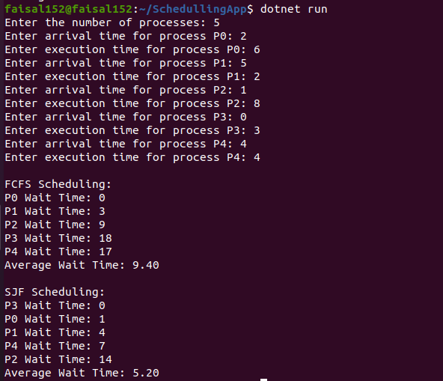

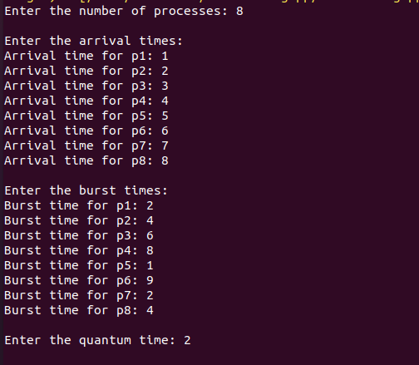

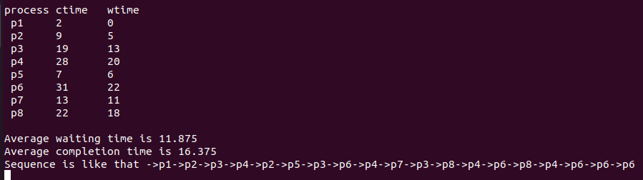

(b)

using System;
using System.Collections.Generic;

public class Process
{
public int Id { get; set; }
public int ArrivalTime { get; set; }
public int BurstTime { get; set; }
public int OriginalBurstTime { get; set; }
public int WaitingTime { get; set; }
public int TurnaroundTime { get; set; }

public Process(int id, int arrivalTime, int burstTime)
{
Id = id;
ArrivalTime = arrivalTime;
BurstTime = burstTime;
OriginalBurstTime = burstTime;
WaitingTime = 0;
TurnaroundTime = 0;
}
}

public class ShortestJobFirst
{
public List<Process> Processes { get; set; }

public ShortestJobFirst(List<Process> processes)
{
Processes = processes;
}

public void Schedule()
{
// Sort processes based on arrival time, then burst time
Processes.Sort((a, b) => {
int compareArrival = a.ArrivalTime.CompareTo(b.ArrivalTime);
if (compareArrival == 0)
{
return a.BurstTime.CompareTo(b.BurstTime);
}
return compareArrival;
});

int currentTime = 0;
int completedProcesses = 0;
int n = Processes.Count;

while (completedProcesses < n)
{
// Find the next shortest job that has arrived
Process shortestProcess = null;
for (int i = 0; i < n; i++)
{
Process proc = Processes[i];
if (proc.ArrivalTime <= currentTime && proc.BurstTime > 0)
{
if (shortestProcess == null || proc.BurstTime < shortestProcess.BurstTime)
{
shortestProcess = proc;
}
}
}

if (shortestProcess != null)
{
// Process the shortest process found
currentTime += shortestProcess.BurstTime;
shortestProcess.TurnaroundTime = currentTime - shortestProcess.ArrivalTime;
shortestProcess.WaitingTime = shortestProcess.TurnaroundTime - shortestProcess.OriginalBurstTime;

// Mark the process as completed
shortestProcess.BurstTime = 0;
completedProcesses++;
}
else
{
// If no process found to execute, just increment the time
currentTime++;
}
}
}

public void DisplayResults()
{
Console.WriteLine();
Console.WriteLine("Process\tArrival\tBurst\tWaiting\tTurnaround");
foreach (var proc in Processes)
{
Console.WriteLine($"{proc.Id}\t{proc.ArrivalTime}\t{proc.OriginalBurstTime}\t{proc.WaitingTime}\t{proc.TurnaroundTime}");
}
}
}

public class Program
{
public static void Main()
{
List<Process> processes = new List<Process>();

Console.Write("Enter the number of processes: ");
int numberOfProcesses = Convert.ToInt32(Console.ReadLine());

for (int i = 1; i <= numberOfProcesses; i++)
{
Console.WriteLine();
Console.Write($"Enter arrival time for process {i}: ");
int arrivalTime = Convert.ToInt32(Console.ReadLine());
Console.Write($"Enter burst time for process {i}: ");
int burstTime = Convert.ToInt32(Console.ReadLine());

processes.Add(new Process(i, arrivalTime, burstTime));
}

// Create a SJF scheduler
ShortestJobFirst sjf = new ShortestJobFirst(processes);

// Schedule the processes
sjf.Schedule();

// Display the results
sjf.DisplayResults();

Console.ReadLine();
}
}
using System;

class Program
{
static int totalprocess;
static int[][] proc;
static int[] arrivaltime;
static int[] bursttime;
static int[] priority;

// Driver code
static void Main(string[] args)
{
// Get the number of processes from the user
Console.Write("Enter the number of processes: ");
totalprocess = int.Parse(Console.ReadLine());

proc = new int[totalprocess][];
arrivaltime = new int[totalprocess];
bursttime = new int[totalprocess];
priority = new int[totalprocess];

// Get arrival time, burst time, and priority for each process
for (int i = 0; i < totalprocess; i++)
{
Console.WriteLine();
Console.Write($"Enter arrival time for process {i + 1}: ");
arrivaltime[i] = int.Parse(Console.ReadLine());

Console.Write($"Enter burst time for process {i + 1}: ");
bursttime[i] = int.Parse(Console.ReadLine());

Console.Write($"Enter priority for process {i + 1}: ");
priority[i] = int.Parse(Console.ReadLine());
}

// Initialize the proc array
for (int i = 0; i < totalprocess; i++)
{

proc[i] = new int[4];
proc[i][0] = arrivaltime[i];
proc[i][1] = bursttime[i];
proc[i][2] = priority[i];
proc[i][3] = i + 1;
}

// Sort by priority and then by arrival time
Array.Sort(proc, (x, y) => x[2].CompareTo(y[2]));
Array.Sort(proc, (x, y) => x[0].CompareTo(y[0]));

Findgc();
Console.ReadLine();
}

// Using FCFS Algorithm to find Waiting time
static void GetWtTime(int[] wt)
{
// Declaring service array that stores cumulative burst time
int[] service = new int[totalprocess];

// Initialising initial elements of the arrays
service[0] = 0;
wt[0] = 0;

for (int i = 1; i < totalprocess; i++)
{
service[i] = proc[i - 1][1] + service[i - 1];
wt[i] = service[i] - proc[i][0] + 1;

// If waiting time is negative, change it to zero
if (wt[i] < 0)
{
wt[i] = 0;
}
}
}

// Filling turnaround time array
static void GetTatTime(int[] tat, int[] wt)
{
for (int i = 0; i < totalprocess; i++)
{
tat[i] = proc[i][1] + wt[i];
}
}

static void Findgc()
{
// Declare waiting time and turnaround time array
int[] wt = new int[totalprocess];
int[] tat = new int[totalprocess];
int wavg = 0;
int tavg = 0;

// Function call to find waiting time array
GetWtTime(wt);

// Function call to find turnaround time
GetTatTime(tat, wt);

int[] stime = new int[totalprocess];
int[] ctime = new int[totalprocess];
stime[0] = 1;
ctime[0] = stime[0] + tat[0];

Console.WriteLine();
Console.WriteLine("Process_no\tStart_time\tComplete_time\tTurn_Around_Time\tWaiting_Time");

// Calculating starting and ending time
for (int i = 0; i < totalprocess; i++)
{
wavg += wt[i];
tavg += tat[i];
Console.WriteLine(proc[i][3] + "\t\t" + stime[i] + "\t\t" + ctime[i] + "\t\t" + tat[i] + "\t\t\t" + wt[i]);

// Display the process details
if (i != totalprocess - 1)
{
stime[i + 1] = ctime[i];
ctime[i + 1] = stime[i + 1] + tat[i + 1] - wt[i + 1];
}
}

Console.WriteLine();
// Display the average waiting time and average turn around time
Console.WriteLine("Average waiting time is: " + (double)wavg / totalprocess);
Console.WriteLine("Average turnaround time is: " + (double)tavg / totalprocess);
}
}

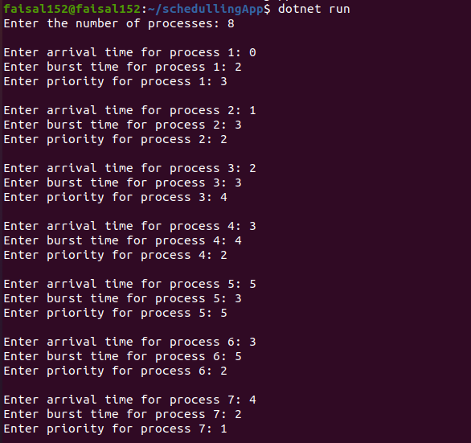

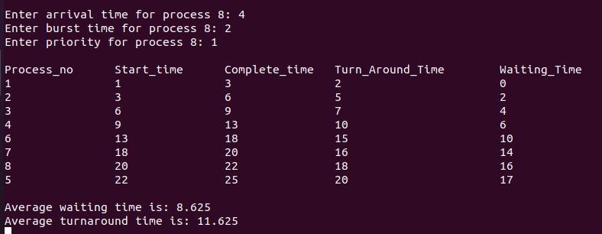

Task 2: Perform the above code with 10 Number of processes by randomly setting the arrival time and burst time and priority.
(a) Use Round Robin Algorithm
(b) Use Priority Based Algorithm

(a)

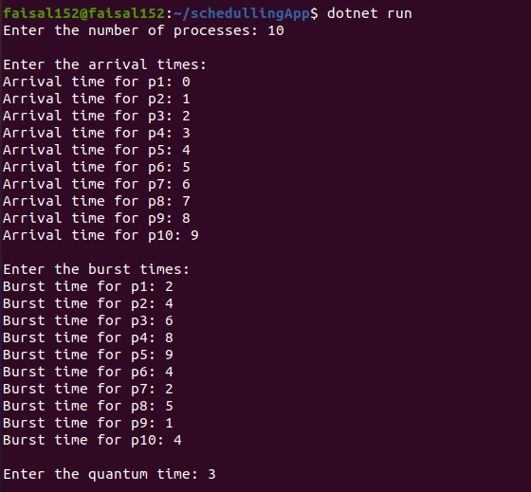

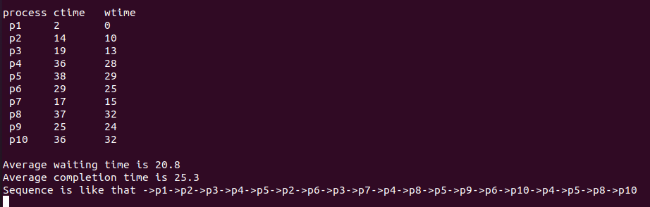

(b)
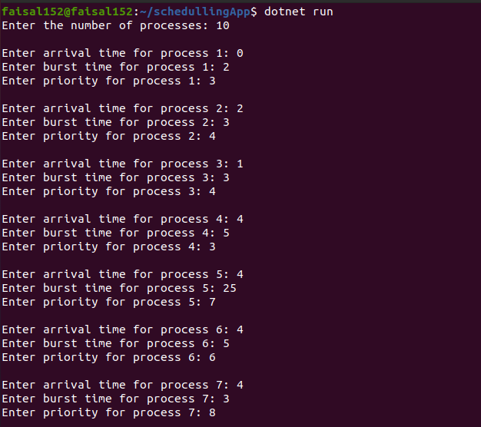
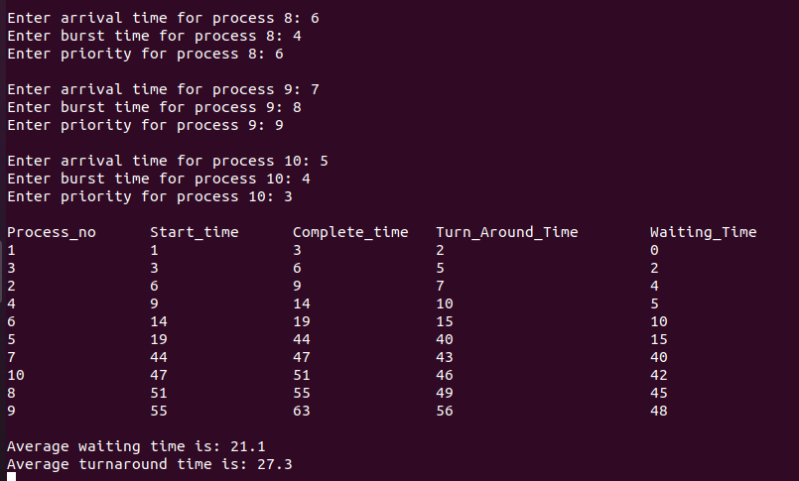

Lab #11

Task 1: Take two inputs from user and then perform arithmetic operations
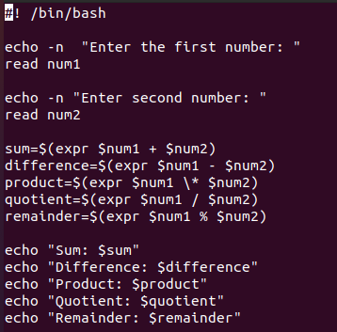

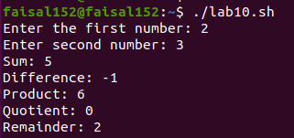

Task 2: Use system variables and user defined variables to show how that value can be accessed.
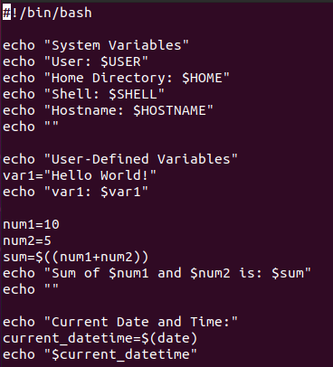



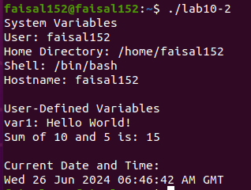

Task 3: Show results of double , single and back quote

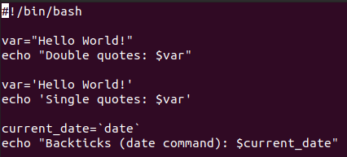

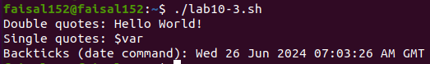

Lab #12

Task 1: Write a program to generate the following output by using while loop
The value of x is 10
The value of x is 9
The value of x is 8
The value of x is 7
The value of x is 6
The value of x is 5
The value of x is 4
The value of x is 3
The value of x is 2
The value of x is 1

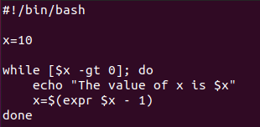

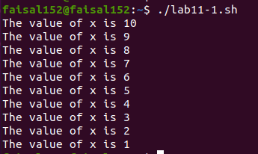

Task 2: Write a program to generate the table of any number by using for loop.

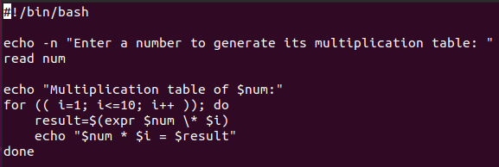

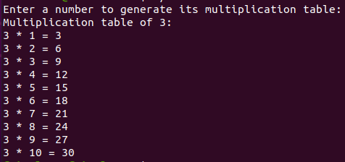

Task 3: Write a program to generate the factorial of a number.

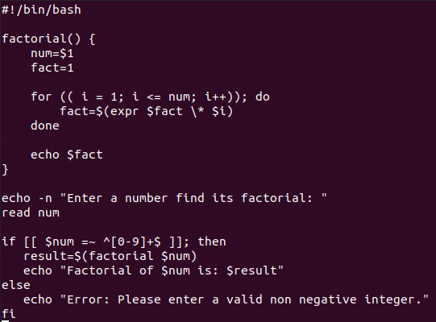

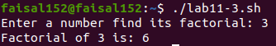

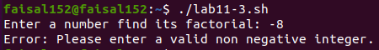

Task 4: Write a program to show the grades and % of students (with students details).
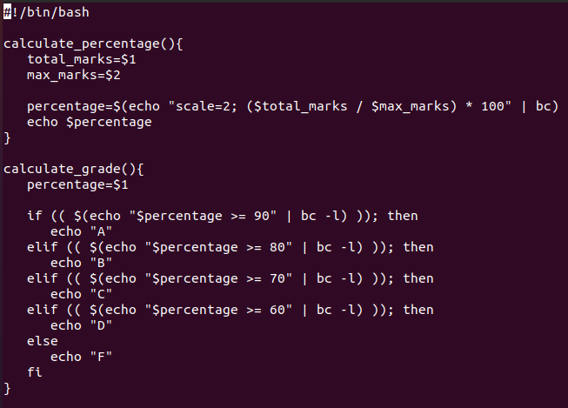

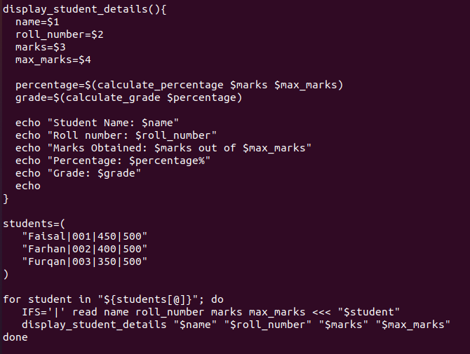

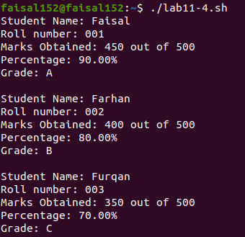

Lab #13

Task 1: Write a Bash script that takes a username as an argument and prints the user's ID, home directory, and login shell using switch case.
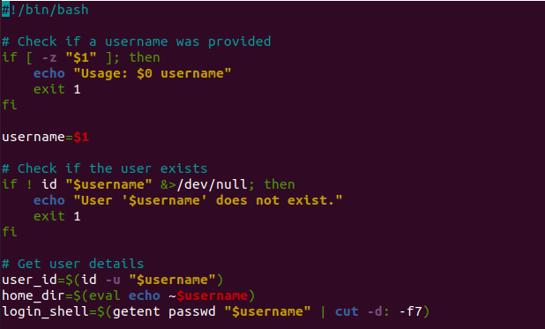

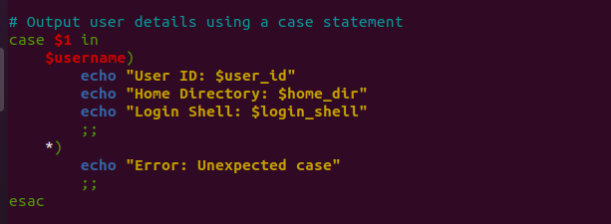

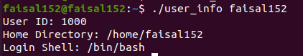

Task 2: Write a Bash script that takes three arguments: two numbers and an operator (+, -, *, /). The script should perform the calculation and print the result handle by using switch case.

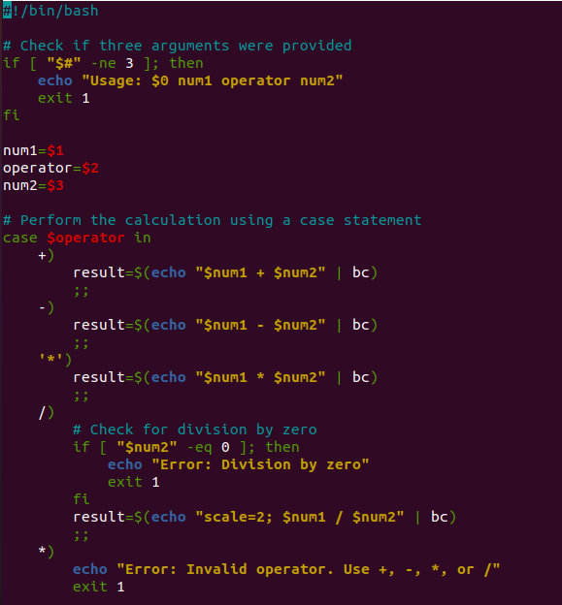

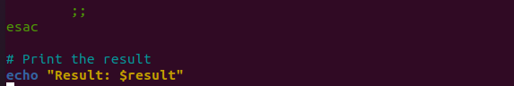


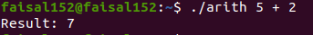

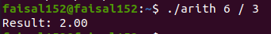
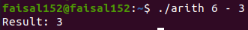

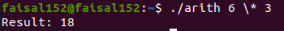

Task 3: Write a Bash script that counts and prints the number of files in a given directory and its subdirectories handle by using switch case.
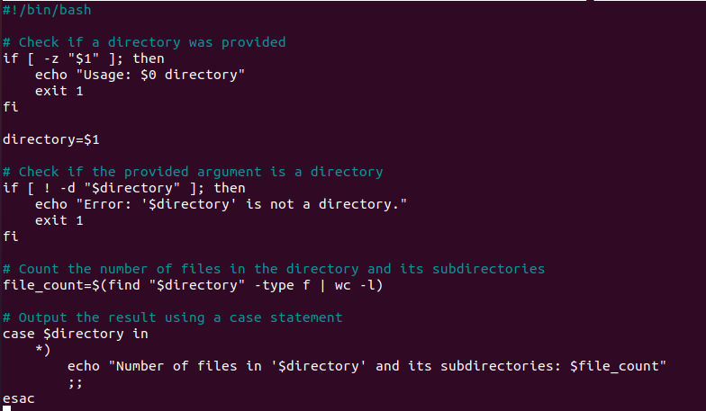

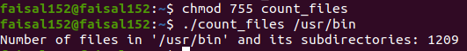

To find Odd or Even no.
a=2
b=0
echo Enter the no.
read x
b=`expr $x % $a`
if [ $b –eq 0 ]
then
echo Given no. is Even
else
echo Given no. is Odd
To reverse a no.
echo Enter the no.
read x
while [$x -gt 0]
do
c=`expr $x % 10`
echo $c
x=`expr $x/10`
done
To print the fibonnicii series
count=1
f1=1
f2=1
k=0
echo $f1
echo $f2
while [ $count -le 10 ]
do
k=`expr $f1 + $f2`
echo $k
f1=$f2
f2=$k
count =`expr $count +1`
done
To find average of two nos.
echo enter the 1st no.
read a
echo enter the 2nd no.
read b
c=`expr $a + $b’
d=$c/2
echo the average of two no. is $d

Task 4: Implement all the above logic using functions

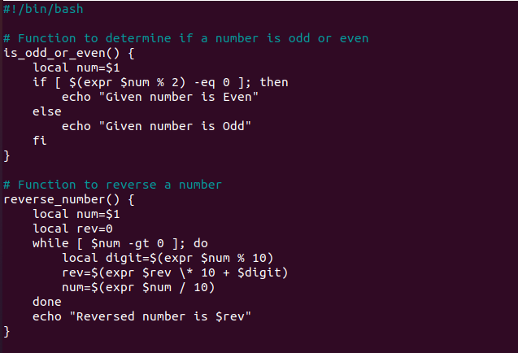

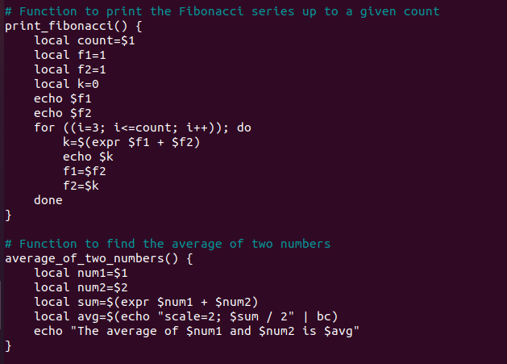



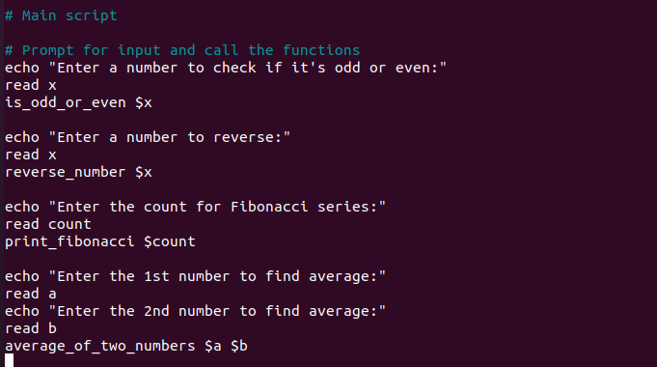

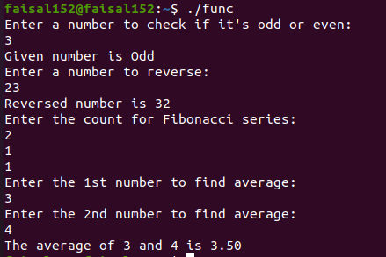

Lab #14

Task 1: Demonstrating Hello World Example
Pre-requisite
Create an account with DockerHub
Open PWD Platform on your browser
Click on Add New Instance on the left side of the screen to bring up Alpine OS instance on the right side

Write command:

$ docker run hello-world
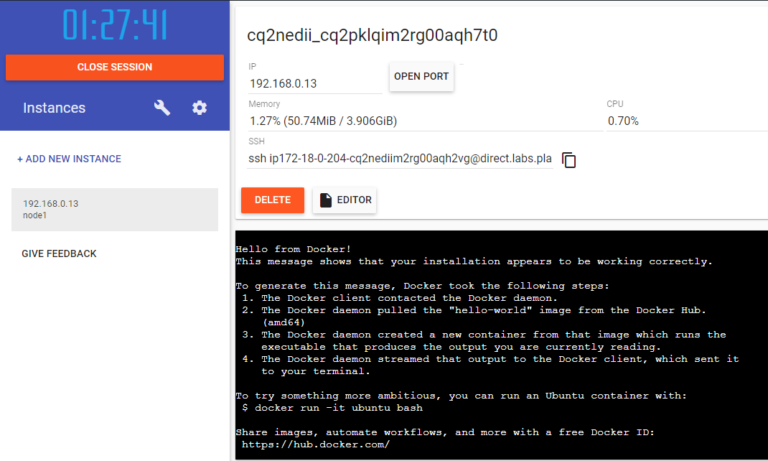

Lab #8

Banker's Algorithm implementation:



using System;

namespace DeadlockDetection
{
class Program
{
static void Main(string[] args)
{
// Number of processes and resources
int n = 5, m = 3;

// Allocation Matrix
int[,] alloc = { { 0, 1, 0 }, // P0
{ 2, 0, 0 }, // P1
{ 3, 0, 2 }, // P2
{ 2, 1, 1 }, // P3
{ 0, 0, 2 } }; // P4

// MAX Matrix
int[,] max = { { 7, 5, 3 }, // P0
{ 3, 2, 2 }, // P1
{ 9, 0, 2 }, // P2
{ 2, 2, 2 }, // P3
{ 4, 3, 3 } }; // P4

// Available Resources
int[] avail = { 3, 3, 2 };

bool[] f = new bool[n];
int[] ans = new int[n];
int[,] need = new int[n, m];

// Calculate the need matrix
for (int i = 0; i < n; i++)
{
for (int j = 0; j < m; j++)
{
need[i, j] = max[i, j] - alloc[i, j];
}
}

int ind = 0;
for (int k = 0; k < n; k++)
{
for (int i = 0; i < n; i++)
{
if (!f[i])
{
bool flag = true;
for (int j = 0; j < m; j++)
{
if (need[i, j] > avail[j])
{
flag = false;
break;
}
}

if (flag)
{
ans[ind++] = i;
for (int y = 0; y < m; y++)
{
avail[y] += alloc[i, y];
}
f[i] = true;
}
}
}
}

Console.WriteLine("Following is the SAFE Sequence:");
for (int i = 0; i < n - 1; i++)
{
Console.Write("P" + ans[i] + " -> ");
}
Console.WriteLine("P" + ans[n - 1]);
}
}
}

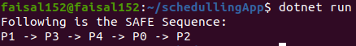

Deadlock Real life Scenario:

using System;
using System.Threading;

public class X
{
public void Display1(X obj2)
{
Console.WriteLine("Thread1 waiting for thread2 to release lock");
lock (obj2)
{
Console.WriteLine("Deadlock occurred");
}
}

public void Display2(X obj1)
{
Console.WriteLine("Thread2 waiting for thread1 to release lock");
lock (obj1)
{
Console.WriteLine("Deadlock occurred");
}
}
}

public class Thread1
{
private X obj1, obj2;

public Thread1(X obj1, X obj2)
{
this.obj1 = obj1;
this.obj2 = obj2;
}

public void Run()
{
lock (obj1)
{
try
{
Thread.Sleep(1000);
}
catch (ThreadInterruptedException ie)
{
Console.WriteLine(ie);
}
obj2.Display2(obj2);
}
}
}

public class Thread2
{
private X obj1, obj2;

public Thread2(X obj1, X obj2)
{
this.obj1 = obj1;
this.obj2 = obj2;
}

public void Run()
{
lock (obj2)
{
try
{
Thread.Sleep(1000);
}
catch (ThreadInterruptedException ie)
{
Console.WriteLine(ie);
}
obj1.Display1(obj1);
}
}
}

public class Deadlock
{
public static void Main(string[] args)
{
X obj1 = new X();
X obj2 = new X();

Thread1 t1 = new Thread1(obj1, obj2);
Thread2 t2 = new Thread2(obj1, obj2);

Thread thread1 = new Thread(new ThreadStart(t1.Run));
Thread thread2 = new Thread(new ThreadStart(t2.Run));

thread1.Start();
thread2.Start();
}
}
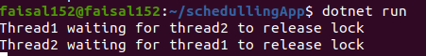

Lab #9

Task 1: Implement the Producer-Consumer pattern?

using System;
using System.Collections.Generic;
using System.Threading.Channels;
using System.Threading.Tasks;

namespace ConsoleAppProducerConsumerPattern
{
class Program
{
static void Main(string[] args)
{
var pc = new ProducerConsumer();
pc.StartChannel();
Console.ReadKey();
}
}

public class ProducerConsumer
{
static int messageLimit = 5;
Channel<string> channel = Channel.CreateBounded<string>(messageLimit);

public void StartChannel()
{
List<string> names = new List<string>
{
"John Smith",
"Jane Smith",
"John Doe",
"Jane Doe"
};

Task producer = Task.Factory.StartNew(() =>
{
foreach (var name in names)
{
channel.Writer.TryWrite(name);
}
channel.Writer.Complete();
});

Task[] consumers = new Task[2];
for (int i = 0; i < consumers.Length; i++)
{
consumers[i] = Task.Factory.StartNew(async () =>
{
while (await channel.Reader.WaitToReadAsync())
{
if (channel.Reader.TryRead(out var data))
{
Console.WriteLine($"Data read from Consumer No.{Task.CurrentId} is {data}");
}
}
});
}

producer.Wait();
Task.WaitAll(consumers);
}
}
}

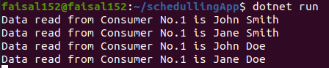

Task 2: What is the purpose of using semaphores?
Semaphores are synchronization tools used to control access to a common resource by multiple processes in a concurrent system such as a multitasking operating system. They are primarily used for two purposes:
Mutual Exclusion: Ensuring that only one process accesses a critical section at a time.
Synchronization: Ensuring that certain operations are performed in a specific order when multiple processes are involved.

Task 3: How are semaphores used in concurrent programming?
Semaphores are used in concurrent programming to manage the access to shared resources. They can be used to solve problems such as the Producer-Consumer problem, Reader-Writer problem, and Dining Philosophers problem. Semaphores can be of two types:
Binary Semaphores: Also known as mutexes, they can have only two values: 0 and 1. They are used for mutual exclusion, ensuring that only one process enters the critical section at a time.
Counting Semaphores: They can have any non-negative integer value. They are used to manage a finite number of resources.

Task 4: Implement the semaphore types with various processes?

Binary Semaphore Implementation:

using System;
using System.Collections.Generic;

public class Process
{
public string Name { get; set; }

public Process(string name)
{
Name = name;
}

public void Sleep()
{
Console.WriteLine($"{Name} is sleeping...");
}

public void Wakeup()
{
Console.WriteLine($"{Name} is waking up...");
}
}

public class Semaphore
{
public enum Value { Zero, One }
public Value value = Value.One;
public Queue<Process> queue = new Queue<Process>();

public void P(Process p)
{
if (value == Value.One)
{
value = Value.Zero;
}
else
{
queue.Enqueue(p);
p.Sleep();
}
}

public void V()
{
if (queue.Count == 0)
{
value = Value.One;
}
else
{
Process p = queue.Dequeue();
p.Wakeup();
}
}
}

class Program
{
static void Main(string[] args)
{
Semaphore semaphore = new Semaphore();
Process p1 = new Process("Process 1");
Process p2 = new Process("Process 2");

semaphore.P(p1);
semaphore.P(p2);

semaphore.V();
semaphore.V();

Console.ReadKey();
}
}
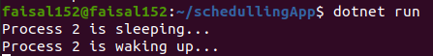

Counting Semaphore Implementation:

using System;
using System.Collections.Generic;

public class Process
{
public string Name { get; set; }

public Process(string name)
{
Name = name;
}

public void Block()
{
Console.WriteLine($"{Name} is blocked...");
}

public void Wakeup()
{
Console.WriteLine($"{Name} is waking up...");
}
}

public class CountingSemaphore
{
public int value;
public Queue<Process> queue = new Queue<Process>();

public CountingSemaphore(int initialValue)
{
value = initialValue;
}

public void P(Process p)
{
value--;
if (value < 0)
{
queue.Enqueue(p);
p.Block();
}
}

public void V()
{
value++;
if (value <= 0)
{
Process p = queue.Dequeue();
p.Wakeup();
}
}
}

class Program
{
static void Main(string[] args)
{
CountingSemaphore semaphore = new CountingSemaphore(1);
Process p1 = new Process("Process 1");
Process p2 = new Process("Process 2");
Process p3 = new Process("Process 3");

semaphore.P(p1);
semaphore.P(p2);
semaphore.P(p3);

semaphore.V();
semaphore.V();
semaphore.V();

Console.ReadKey();
}
}
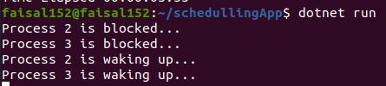

Lab #10

Task 1: For below processes, and block sizes, provide results using algorithms for below
- First Fit
- Best Fit and
- Worst Fit
Block Size [] = {200,400,600,500,300,250};
Process Size [] = {357,210,468,491};

First Fit:

using System;

class FirstFit
{
// Method to allocate memory to blocks as per First Fit algorithm
static void firstFit(int[] blockSize, int m, int[] processSize, int n)
{
// Stores block id of the block allocated to a process
int[] allocation = new int[n];

// Initially no block is assigned to any process
for (int i = 0; i < allocation.Length; i++)
allocation[i] = -1;

// Pick each process and find suitable blocks according to its size and assign to it
for (int i = 0; i < n; i++)
{
for (int j = 0; j < m; j++)
{
if (blockSize[j] >= processSize[i])
{
// Allocate block j to p[i] process
allocation[i] = j;

// Reduce available memory in this block
blockSize[j] -= processSize[i];

break;
}
}
}

Console.WriteLine("\nProcess No.\tProcess Size\tBlock no.");
for (int i = 0; i < n; i++)
{
Console.Write(" " + (i + 1) + "\t\t" + processSize[i] + "\t\t");
if (allocation[i] != -1)
Console.Write(allocation[i] + 1);
else
Console.Write("Not Allocated");
Console.WriteLine();
}
}

// Driver Code
public static void Main()
{
Console.WriteLine("Enter the block sizes separated by spaces:");
string[] blockSizeInput = Console.ReadLine().Split(' ');
int[] blockSize = Array.ConvertAll(blockSizeInput, int.Parse);

Console.WriteLine("Enter the process sizes separated by spaces:");
string[] processSizeInput = Console.ReadLine().Split(' ');
int[] processSize = Array.ConvertAll(processSizeInput, int.Parse);

int m = blockSize.Length;
int n = processSize.Length;

firstFit(blockSize, m, processSize, n);
}
}
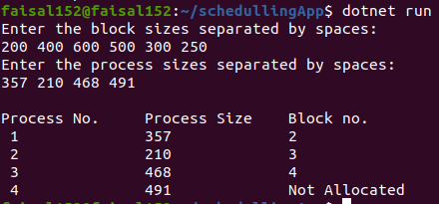

Best Fit
using System;

public class BestFit
{
// Method to allocate memory to blocks as per Best fit algorithm
static void bestFit(int[] blockSize, int m, int[] processSize, int n)
{
// Stores block id of the block allocated to a process
int[] allocation = new int[n];

// Initially no block is assigned to any process
for (int i = 0; i < allocation.Length; i++)
allocation[i] = -1;

// Pick each process and find suitable blocks according to its size and assign to it
for (int i = 0; i < n; i++)
{
// Find the best fit block for current process
int bestIdx = -1;
for (int j = 0; j < m; j++)
{
if (blockSize[j] >= processSize[i])
{
if (bestIdx == -1)
bestIdx = j;
else if (blockSize[bestIdx] > blockSize[j])
bestIdx = j;
}
}

// If we could find a block for current process
if (bestIdx != -1)
{
// Allocate block j to p[i] process
allocation[i] = bestIdx;

// Reduce available memory in this block
blockSize[bestIdx] -= processSize[i];
}
}

Console.WriteLine("\nProcess No.\tProcess Size\tBlock no.");
for (int i = 0; i < n; i++)
{
Console.Write(" " + (i + 1) + "\t\t" + processSize[i] + "\t\t");
if (allocation[i] != -1)
Console.Write(allocation[i] + 1);
else
Console.Write("Not Allocated");
Console.WriteLine();
}
}

// Driver Method
public static void Main()
{
Console.WriteLine("Enter the block sizes separated by spaces:");
string[] blockSizeInput = Console.ReadLine().Split(' ');
int[] blockSize = Array.ConvertAll(blockSizeInput, int.Parse);

Console.WriteLine("Enter the process sizes separated by spaces:");
string[] processSizeInput = Console.ReadLine().Split(' ');
int[] processSize = Array.ConvertAll(processSizeInput, int.Parse);

int m = blockSize.Length;
int n = processSize.Length;

bestFit(blockSize, m, processSize, n);
}
}

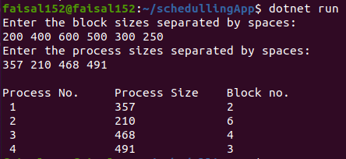

Worst Fit:
using System;

class WorstFit
{
// Method to allocate memory to blocks as per worst fit algorithm
static void worstFit(int[] blockSize, int m, int[] processSize, int n)
{
// Stores block id of the block allocated to a process
int[] allocation = new int[n];

// Initially no block is assigned to any process
for (int i = 0; i < allocation.Length; i++)
allocation[i] = -1;

// Pick each process and find suitable blocks according to its size and assign to it
for (int i = 0; i < n; i++)
{
// Find the worst fit block for current process
int wstIdx = -1;
for (int j = 0; j < m; j++)
{
if (blockSize[j] >= processSize[i])
{
if (wstIdx == -1)
wstIdx = j;
else if (blockSize[wstIdx] < blockSize[j])
wstIdx = j;
}
}

// If we could find a block for current process
if (wstIdx != -1)
{
// Allocate block j to p[i] process
allocation[i] = wstIdx;

// Reduce available memory in this block
blockSize[wstIdx] -= processSize[i];
}
}

Console.WriteLine("\nProcess No.\tProcess Size\tBlock no.");
for (int i = 0; i < n; i++)
{
Console.Write(" " + (i + 1) + "\t\t\t" + processSize[i] + "\t\t\t");
if (allocation[i] != -1)
Console.Write(allocation[i] + 1);
else
Console.Write("Not Allocated");
Console.WriteLine();
}
}

// Driver code
public static void Main(String[] args)
{
Console.WriteLine("Enter the block sizes separated by spaces:");
string[] blockSizeInput = Console.ReadLine().Split(' ');
int[] blockSize = Array.ConvertAll(blockSizeInput, int.Parse);

Console.WriteLine("Enter the process sizes separated by spaces:");
string[] processSizeInput = Console.ReadLine().Split(' ');
int[] processSize = Array.ConvertAll(processSizeInput, int.Parse);

int m = blockSize.Length;
int n = processSize.Length;

worstFit(blockSize, m, processSize, n);
}
}

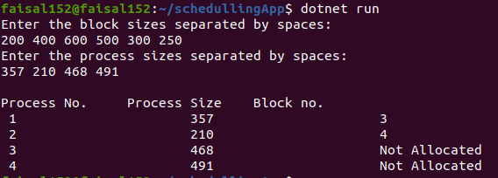

Task 2: For below processes, and block sizes, provide results using algorithms for below
- First Fit
- Best Fit and
- Worst Fit
Block Size [] = {50,150,300,350,600};
Process Size [] = {300, 25, 125, 50};

First Fit:
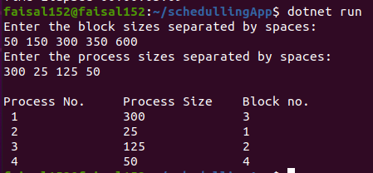

Best First:
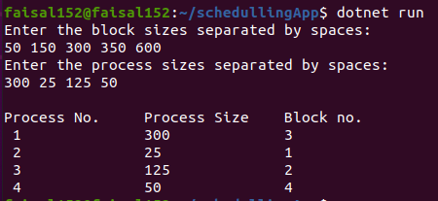

Worst Fit :
